
Docusign Envelope ID: 1291E394-9D22-4D53-8896-3BECAF6BBD92


Associate to Bachelors (A2B) Articulation Agreement
Prescribed Curriculum: Northeast Community College

Associate of Science – Pre-Engineering (Civil)

General Education Courses |  |  |  | 34 CREDIT HOURS
 | Credit Hours | Community College Course No. | Course Title or Category
Written Comm | 3 | ENGL 2070, or  ENGL 1010 | Technical Communications I, or  English Composition I
Oral Communication | 3 | SPCH 1010, or  SPCH 1110 | Fundamentals of Communication, or  Public Speaking
Behavioral & Social Sciences | 3 | Select 1 course from | AS General Education list, except AGRI 1530
English/Literature | 3 | Select 1 course from | AS General Education list, except ENGL 1020
Fine Arts and Language | 3 | Select 1 course from | AS General Education list
Mathematics | 10 | MATH 1600  MATH 2010 | Analytic Geometry and Calculus I  Analytic Geometry and Calculus II
Natural Science | 9 | CHEM 1090  PHYS 2110 | General Chemistry I  General Physics I w/Calculus

Required Courses |  |  | 18 CREDIT HOURS
 | Credit Hours | Course No. | Course Title
Mathematics, Science, and Engineering | 4* | CHEM 1100 | General Chemistry II
Mathematics, Science, and Engineering | 3 | ENGR 1010 | Introduction to Engineering Design
Mathematics, Science, and Engineering | 3 | ENGR 2020 | Engineering Statics
Mathematics, Science, and Engineering | 5 | MATH 2020 | Analytic Geometry and Calculus III
Mathematics, Science, and Engineering | 3 | MATH 2100 | Differential Equations

Program Elective Courses |  |  | 11 CREDIT HOURS
 | Credit Hours | Course No. | Course Title
Program Course | 3 | ENGR 1020 | Programming and Problem Solving
Program Electives | 2 | ARCH 2150 | Civil Drafting
Program Electives | 3 | ARCH 2100 | Surveying and Site Planning
Program Electives | 3 | PHYS 2150 | Structural Analysis

Associate of Science – Pre-Engineering (Civil) Total: | 63 CREDIT HOURS  *(62 Credits Apply)

Post-Associate Degree Prescribed Curriculum: South Dakota Mines

Bachelor of Science – Civil Engineering

General Education Courses |  |  |  | 6 CREDIT HOURS
 | Credit Hours | Community College Course No. | Course Title or Category
Written Communication | 3 | ENGL 289 | Explorations in STEM Communications
Social Sciences | 3 | Select 1 course from | Civics CIV 100, HIST 151, HIS 152, POLS 100, or POLS 210

Major Required Courses |  |  | 48 CREDIT HOURS
 | Credit Hours | Course No. | Course Title
Civil Engineering | 3 | EM 331 | Fluid Mechanics
Civil Engineering | 3 | CEE 274 | Construction Engineering and Management
Civil Engineering | 3 | CEE 325 | Introduction to Sustainable Design
Civil Engineering | 3 | CEE 326 | Environmental Engineering and Science I
Civil Engineering | 3 | CEE 284 | Applied Numerical Methods
Civil Engineering | 3 | EM 321 | Mechanics of Materials
Civil Engineering | 3 | CEE 316/316L | Engineering and Construction Materials w/Lab
Civil Engineering | 3 | CEE 336/336L | Hydraulic Systems Design w/Lab
Civil Engineering | 3 | CEE 346/346L | Geotechnical Engineering w/Lab
Civil Engineering | 3 | CEE 353 | Structural Theory
Civil Engineering | 3 | CEE 468 | Highway Engineering
Civil Engineering | 9 | Select 3 courses from | CEE 327/327L, CEE 337, CEE 347/347L, or CEE 456
Civil Engineering | 3 | CEE 463 | Concepts of Professional Practice
Civil Engineering | 3 | CEE 489 | Capstone Design Project

Other Required Courses |  |  | 5 CREDIT HOURS
 | Credit Hours | Course No. | Course Title
Mathematics | 3 | MATH 381 | Introduction to Probability and Statistics
Economics | 2 | IENG 301 | Basic Engineering Economics

Elective Courses |  |  | 9 CREDIT HOURS
 | Credit Hours | Course No. | Course Title
Dept Approved | 9 | Select from list | Department Approved Electives

Post-Associate Degree Total: | 68 CREDIT HOURS

Bachelor of Science – Civil Engineering Total: | 130 CREDIT HOURS

A2B Articulation Agreement Guarantees & Limitations
GUARANTEES
Students who:
- complete the Associate of Science – Pre-Engineering degree prescribed curriculum at Northeast Community College exactly as it is identified in this articulation agreement, and
- have the degree conferred on their education record at Northeast Community College (post high school graduation), and
- earn a minimum cumulative grade point average (GPA) of 2.75 at the Northeast Community College, and
- pass all 63 credits for the associate degree, earning a grade C- or higher in each course

are guaranteed the following at the South Dakota School of Mines and Technology (South Dakota Mines):
- junior standing at South Dakota Mines with no more than 68 remaining credits to meet the graduation requirements for the Bachelor of Science degree in Civil Engineering.
- admission to South Dakota Mines
- admission to the Bachelor of Science degree in Civil Engineering.

LIMITATIONS
- This agreement is between the Associate of Science – Pre-Engineering degree at Northeast Community College and the Bachelor of Science degree in Civil Engineering at South Dakota Mines only.
- Students must meet all admission and application requirements at South Dakota Mines, including the submission of all required documentation by stated deadlines. Students are advised to contact the Office of Admissions at the South Dakota Mines early in their transfer planning.
- Student must have a cumulative grade point average (GPA) at the Northeast Community College of 2.75 or higher
and only courses with grades of C- or higher are guaranteed to be accepted in transfer by South Dakota Mines.
- The credit and course transfer guarantees described in this agreement apply to the Associate of Science – Pre- Engineering degree at Northeast Community College and the Bachelor of Science degree in Civil Engineering at South Dakota Mines. If the student changes majors at Northeast Community College or at South Dakota Mines, the student is no longer covered by this Articulation Agreement and none of the Guarantees of the Agreement apply.
- Students utilizing any form of transfer credit, including but not limited to credit awarded from other higher education institutions, standardized exam (CLEP, AP, DSST, etc.), prior learning assessment (military, certifications, ACE recommended credit, portfolio, challenge exam, work experience equivalent credit, etc.) to satisfy any Associate degree requirements will have those credits evaluated by South Dakota Mines. Should South Dakota Mines not accept the transfer credits accepted by Northeast Community College, the student will be required to make up the credit deficiency at South Dakota Mines.
- No course substitutions are allowed for the courses listed in the Prescribed Curriculum for the associate degree at Northeast Community College.

A2B CONTACT INFORMATION
South Dakota Mines Northeast Community College
Office of the Provost Registration Office
605.394.2256 402.844.7265
Provost@sdsmt.edu

RENEWAL, REVISION, and TERMINATION
- This Associate to Bachelor Articulation Agreement (A2B) shall be in effect July 1 – June 30 each year and will automatically renew annually unless action is taken by South Dakota Mines or Northeast Community College to terminate or modify it.
- The South Dakota Mines Office of the Provost and the Northeast Community College Academic Affairs division will collaborate to coordinate a review of the content of the associate and bachelor degrees on a three-year cycle to ensure this A2B is still appropriate.
- South Dakota Mines and the Northeast Community College each reserve the right to seek revision of this agreement at any time.
- Revision of any content of the agreement (except Appendices content) will be approved by each institution and result in a new agreement being signed, with copies retained by each institution.
  - Revision to any Appendices will be communicated to each institution, but do not need to be approved by each institution and will not result in a new agreement being signed by each institution.
- South Dakota Mines and the Northeast Community College each reserve the right to seek termination of this agreement at any time.
- Should the agreement be terminated, each institution agrees to collaborate and engage in appropriate plans to notify and work with impacted students, providing a minimum one-year advance notice of termination.

APPROVALS

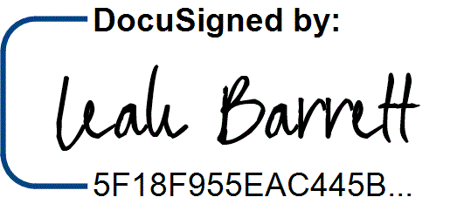
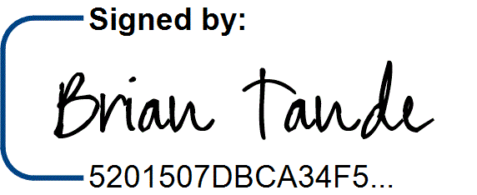
7/29/2025 7/28/2025
Brian Tande, Ph.D. Date Leah Barrett, Ed.D. Date President President
South Dakota Mines Northeast Community College
Brian.Tande@sdsmt.edu lbarrett@northeast.edu

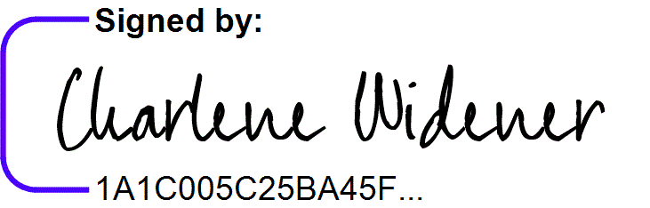

7/29/2025 7/25/2025
Lance Roberts, Ph.D. Date Charlene Widener, Ph.D. Date Provost and Vice President for Academic Affairs Vice President of Educational Services
South Dakota Mines Northeast Community College
Lance.Roberts@sdsmt.edu cwidener@northeast.edu

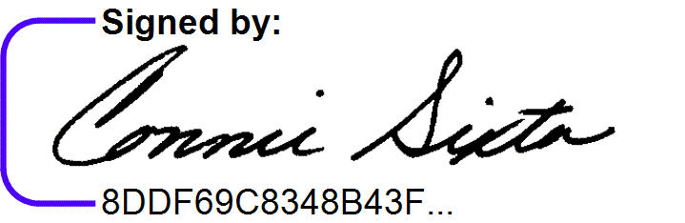
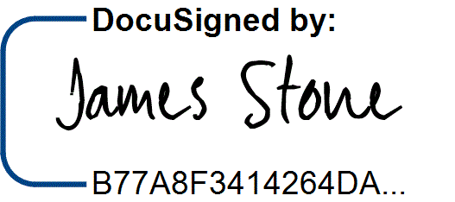
7/28/2025 7/25/2025
James Stone, Ph.D. Date Connie Sixta Date Department Head Dean of Science, Technology, Agriculture & Math
South Dakota Mines Northeast Community College
James.Stone@sdsmt.edu connie@northeast.edu

Appendix A: Course Sequence


Course Sequence: Northeast Community College

Pre-Engineering - Civil (A.S.)

Semester | Course No. | Course Title | Credit Hours | Completed
Freshman | ENGL 2070 | Technical Communications I (or ENGL 1010 English Comp) | 3
Year
Year | MATH 1600 | Analytic Geometry and Calculus I | 5
First
First | CHEM 1090 | General Chemistry I | 4
Semester
Semester | ENGR 1010 | Introduction to Engineering Design | 3
 |  | Total Credits | 15

Semester | Course No. | Course Title | Credit Hours | Completed
Freshman | Select 1 course from | English/Literature (except ENGL 1020) | 3
Year
Year | MATH 2010 | Analytic Geometry and Calculus II | 5
Second
Second | PHYS 2110 | General Physics I with Calculus | 5
Semester
Semester | ENGR 1020 | Programming and Problem Solving | 3
 |  | Total Credits | 16

Semester | Course No. | Course Title | Credit Hours | Completed
Sophomore | ENGR 2020 | Engineering Statics | 3
Year
Year | MATH 2100 | Differential Equations | 3
First
First | Select 1 course from | Behavioral and Social Sciences (except AGRI 1530) | 3
Semester
Semester | ARCH 2150 | Civil Drafting | 2
 | ARCH 2100 | Surveying and Site Planning | 3
 |  | Total Credits | 14

Semester | Course No. | Course Title | Credit Hours | Completed
Sophomore | Select 1 course from | Fine Arts and Language | 3
Year
Year | MATH 2020 | Analytic Geometry and Calculus III | 5
Second
Second | Select 1 course from | SPCH 1010 (Fund of Comm) or SPCH 1110 (Public Speaking) | 3
Semester
Semester | CHEM 1100 | General Chemistry II | 4
 | PHYS 2150 | Structural Analysis | 3
 |  | Total Credits | 18

General Education Coursework Total:  Major and Elective Coursework Total:  Northeast Community College Coursework Total: | 34 credit hours  29 credit hours  63 CREDIT HOURS


Course Sequence: South Dakota Mines – Fall Semester Start

Civil Engineering (B.S.)

Semester | Course No. | Course Title | Credit Hours | Completed
Junior Year First Semester  - FALL | EM 331 | Fluid Mechanics | 3
Junior Year First Semester  - FALL | CEE 284 | Applied Numerical Methods | 3
Junior Year First Semester  - FALL | EM 321 | Mechanics of Materials | 3
Junior Year First Semester  - FALL | MATH 381 | Introduction to Probability and Statistics | 3
Junior Year First Semester  - FALL | ENGL 289 | STEM Communication for Technical & Public Audiences | 3
Junior Year First Semester  - FALL | Select 1 course from | Social Science (Goal 3) - Civics CIV 100, HIST 151, HIS 152,  POLS 100, or POLS 210 | 3
Total Credits 18

Semester | Course No. | Course Title | Credit Hours | Completed
Junior Year | CEE 274 | Construction Engineering and Management | 3
Second
Second | CEE 326 | Environmental Engineering and Science I | 3
Semester -
Semester - | CEE 325 | Introduction to Sustainable Design | 3
SPRING
SPRING | IENG 302 | Engineering Economics | 3
 |  | Department Approved Electives | 6
 |  | Total Credits | 18

Semester | Course No. | Course Title | Credit Hours | Completed
Senior Year First Semester  - FALL | CEE 316/316L | Engineering and Construction Materials w/Lab | 3
Senior Year First Semester  - FALL | CEE 336/336L | Hydraulic Systems Design w/Lab | 3
Senior Year First Semester  - FALL | CEE 346/346L | Geotechnical Engineering w/Lab | 3
Senior Year First Semester  - FALL | CEE 353 | Structural Theory | 3
Senior Year First Semester  - FALL | CEE 463 | Concepts of Professional Practice | 2
Senior Year First Semester  - FALL |  | Department Approved Electives | 3
Total Credits 17

Semester | Course No. | Course Title | Credit Hours | Completed
Senior Year | CEE 468 | Highway Engineering | 3
Second
Second | Select 3 courses from | CEE 327/327L, CEE 337, CEE 347/347L, or CEE 456 | 9
Semester -
Semester - | CEE 489 | Capstone Design | 3
SPRING
 |  | Total Credits | 15

General Education Coursework Total:  Major and Elective Coursework Total:  South Dakota Mines Coursework Total: | 6 credit hours  62 credit hours  68 CREDIT HOURS

